Template – CRM RFI Form
The template named “Template – CRM RFI Form” is applicable to Anthology CRM.

Purpose and Outcome
This template provides a form sequence and supporting workflow for a basic Request for Information form which captures the users contact details (name, email, etc.) and area of interest (program, term).
The workflow checks the CRM database for a duplicate email address. If a lead record is found with the same email address, the existing lead will be updated with the information provided in the form. If no matching email address is found, a new lead record will be created. Once the lead record is updated or created, the workflow sends a confirmation email to the user. In case of errors, for a better user experience, the form will not show any error messages.

Prerequisites
The template was built with Forms Builder using the applications listed below. The template is forward compatible with later versions of the listed applications.
Application | Compatibility Version
Forms Builder Designer and Renderer | Compatibility Matrix
Web Client for Anthology Student
Workflow Composer
Packages installed from Package Manager in Workflow Composer | Activities and Contracts (V2)  Contracts (V1)  Forms Builder Contracts  Note: Ensure that the Forms Builder Contracts package used in Workflow Composer is aligned with the version used in the Forms Builder. Additionally, confirm that both Activities and Contracts (V1) and Activities and Contracts (V2) packages in Workflow Composer match the versions used in the Student Web Client to avoid compatibility issues.  It depends on which product is being used, for example:  For CRM:  Activities And Contracts (CRM)  Forms Builder Contracts
Workflow Tracking Database | N/A
Staff STS | 3.3.x

Configuration
The web.config file in the CMCFormsRenderer_V3 folder must contain the following:
- SMTP settings to enable confirmation emails to be sent
- Database connection details to enable the workflow to query the database (see ExecuteDataReader activity.

Step 1: Download and Import the Template
- Download the template file to your environment (local drive or network location).
- Log into Forms Builder Designer.
- Click the Export/Import tile.
- Select the Import tab.
- Click Select exported file and navigate to the downloaded template file.
- Click Import.
Note: Import may fail if same files name is already available in environment or overwrite option.
- Export/Import
The following forms will be imported:
- FB_Lead,
- CMC Confirmation

Step 2: In Form Designer…
- From the Forms slide out, select the FB_Lead form.
- Customize the form for your environment. Modify properties on fields/components to make them required, etc., or add/remove fields on form.
Make sure you edit the text in the Labels and HTML controls as applicable for your institution.
- Fields and Components
- Save the form.
- Repeat steps 1-3 for the CMC Confirmation form.

Step 3: In Sequence Designer…
- Locate the CRM RFI sequence in the Sequences pane.
- Click Save As to create a copy of the sequence/workflow and customize the copy for your use. This way you can always refer to the original sequence/workflow you downloaded.
- Optional - Add a custom style (theme) associated with your campus.
- Themes
- Select your saved sequence in the Sequences pane.
- In the Properties Pane:
  - Ensure that the Authentication Product is CRM.
- Select the End State Form named “CMC Confirmation”.
- Save the sequence.

Step 4: In Workflow Composer…
This template does not require any changes to the workflow. The steps below just point out the elements in the workflow and to provide references for additional information.
- Open the workflow for your CRM RFI sequence.
- Opening Workflows for Sequences
- Select the Arguments tab and note that the lead argument has been created due to entity fields on form.
- Updating a Form After Creation of a Sequence and Binding.
- Double-click the FB_Lead state and note the CreateEntity<Lead> activity.
- CreateEntity activity
- Double-click the Next transition and note the WaitForFormBookmark activity in the Trigger section.
- WaitForFormBookmark activity
- The Sequence in the Action section of the Next transition contains a TryCatch activity which provides error handling functionality.
- TryCatch activity
- Double-click and expand the Sequence within the TryCatch activity. Note that the Sequence container holds an ExecuteDataReader activity and an If activity.
- Review the properties of the ExecuteDataReader activity.
The template uses the following property values:
- CommandText = "Select top 1 Aid from tblobjecttype20005 with(nolock) where tleademail= '" & lead.Email & "'"
- ConnectionStringName = "crmconnection"
The ExecuteDataReader activity executes a query on the email addresses in the CRM database. The query will work only if the workflow can connect to the CRM database. Therefore, the following line needs to be added to web.config file in the CMCFormsRenderer_V3 folder of your Forms Builder installation:
<add name="crmconnection" providerName="System.Data.SqlClient" connectionString="Data Source=crmdb_server;initial catalog=crm_database;Integrated Security=SSPI;Persist Security Info=False;MultipleActiveResultSets=True" />
Where:
- The name value (in our example “crmconnection”) needs to match the ConnectionStringName in the ExecuteDataReader activity.
- crmdb_server and crm_database need to be set correctly for your environment
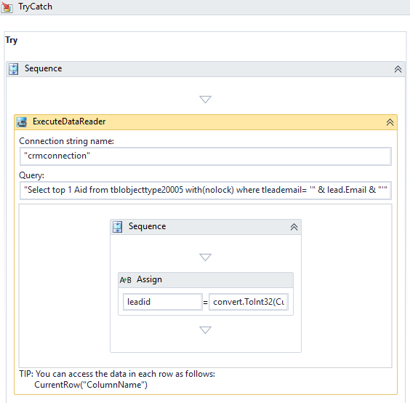
- ExecutedataReader activity
- Review the logic of the If activity.
- If the Condition leadid>1 is met (i.e., an email address matching the form entry was found in the CRM database), then the lead entity is retrieved, and the lead record is updated with the information provided in the form.
- If the Condition leadid>1 is not met (i.e., an email address matching the form entry was not found in the CRM database), then a new lead entity is created with the information provided in the form.
In both cases, a confirmation message is sent.

Step 5: In Forms Renderer…
Select your sequence and try it out! You should have a new prospect created upon completion.
- Sequence List
- Find your CRM RFI sequence and copy the URL to the clipboard.
- Paste the URL into a browser and complete the form sequence.
- Verify that a confirmation message is sent to the email address provided in the form
- In Anthology CRM, verify that the lead record is updated created containing the information submitted in the RFI form.

Step 6: Lastly…
Once your updated sequence has been tested successfully, it is recommended that you disable the workflow for the original Template version.
- In Workflow Composer, in the Server section of the ribbon, click Open.
- Find the workflow named CRM RFI Sequence.
- Clear the Enabled check box and click Save.

